Workflow Functional Document

Application | NGERP - Centra
Workflow | Procure To Pay
Workflow Item Name | NTA PO created and Allocation with NTA Payment

Description:

In NGERP System, NTA Purchase Order(With NTA Product/Charge/Description) is created (or) imported to store the details of the NTA Purchase Order and NTA Goods Receipt, NTA AP Invoice, NTA AP Payment is created against the NTA Purchase Order and then the Invoice will be allocated with Payment.
Workflow Process:

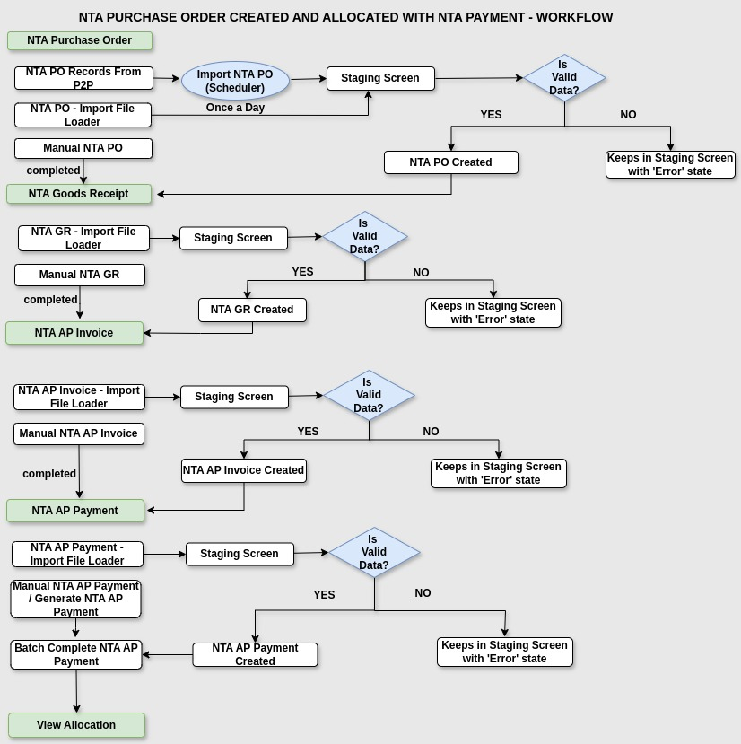

Business Rules:

- We can create NTA Purchase Order document with NTA Product/Charge/Description by three ways :
1. From P2P - NTA PO details will export from P2P System and stored in ‘P2P’ Folder in Server Machine.
Then, ‘Import NTA PO’ Scheduler will run once a day and it will fetch the NTA PO Details from ‘P2P’ Folder and move it to Staging Screen. In Staging Screen, there are some Valida tions. If the Validations are correct, then the NTA PO will be created with ‘Completed’ State.
2. Import File Loader – Importing NTA Purchase Order records using Import File Loader Function will move them into Staging Screen.In Staging Screen, there are some Validations. If the Validations are correct, then the NTA PO will be created with ‘Completed’ State.
3. Manual NTA PO – We can also create NTA Purchase Order documents manually.
Then, the NTA Goods Receipt document will be created against the NTA Purchase Order documents.

- We can create NTA Goods Receipt document by two ways :
1. Import File Loader – Importing NTA Goods Receipt records using Import File Loader Function will move them into Staging Screen.In Staging Screen, there are some Validations. If the Validations are correct, then the NTA GR will be created with ‘Completed’ State.
2. Manual NTA GR – We can also create NTA Goods Receipt documents manually.
Then, the NTA AP Invoice document will be created against the NTA Goods Receipt documents.

- We can create NTA AP Invoice document by two ways :
1. Import File Loader – Importing NTA AP Invoice records using Import File Loader Function will move them into Staging Screen.In Staging Screen, there are some Validations. If the Validations are correct, then the NTA AP Invoice will be created with ‘In Progress’ State.
2. Manual NTA AP Invoice – We can also create NTA AP Invoice documents manually.
Then, the NTA AP Payment document will be created.

- We can create NTA AP Payment document by three ways :
1. Import File Loader – Importing NTA AP Payment records using Import File Loader Function will move them into Staging Screen. In Staging Screen, there are some Validations. If the Validations are correct, then the NTA AP Invoice will be created with ‘In Progress’ State.
2. Generate NTA AP Payment – We can also create NTA AP Payment using Generate NTA AP Payment Form. By creating NTA AP Payment using Generate AP Payment, Allo cation will be created automatically with ‘In Progress’ state.
3. Manual NTA AP Payment – We can also create NTA AP Payment documents manually.
Then, the NTA AP Payment will be allocated with NTA AP Invoice.

- View Allocation – Need to allocate NTA AP Invoice document with NTA AP Payment document.

